SQL Commands for Analysis of Video Game sales

1. Best year for gaming as per sales

select Year, cast(sum(Global_sales) as decimal (10,2))as total_yearly_sales

from vgsales

group by Year

order by total_yearly_sales DESC;

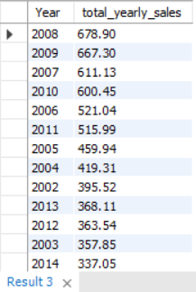

1. Top 5 Publisher by sales

SELECT Publisher, CAST(SUM(Global_sales) as DECIMAL (10,2)) as total_pub_sales

FROM vgsales

GROUP BY Publisher

ORDER BY total_pub_sales DESC;

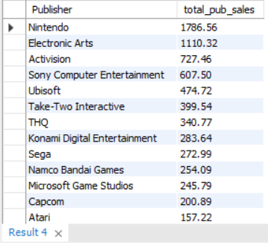

1. Top 5 genre by sales

SELECT Genre, CAST(SUM(Global_sales) as DECIMAL (10,2)) as total_pub_sales

FROM vgsales

GROUP BY Genre

ORDER BY total_pub_sales DESC

LIMIT 5;

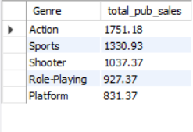

1. Top 5 platform by sales

SELECT Platform, CAST(SUM(Global_sales) as DECIMAL (10,2)) as total_plat_sales

FROM vgsales

GROUP BY Platform

ORDER BY total_plat_sales DESC

LIMIT 5;

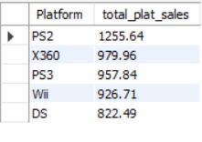

1. Best performing games in north America

SELECT Name, CAST(SUM(NA_Sales) as DECIMAL(10,2)) as NA_Sales

FROM vgsales

GROUP BY Name

ORDER BY NA_Sales DESC;

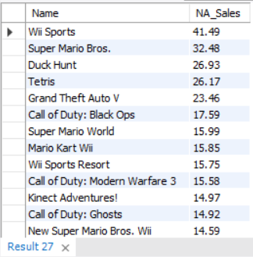

1. Best performing games in Japan

SELECT Name, CAST(SUM(JP_Sales) as DECIMAL(10,2)) as JP_Sales

FROM vgsales

GROUP BY Name

ORDER BY JP_Sales DESC;

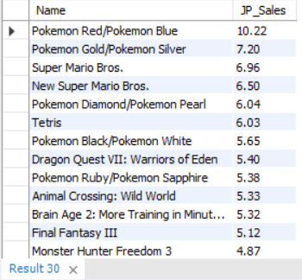

1. Best performing games Rest of the world

SELECT Name, CAST(SUM(Other_Sales) as DECIMAL(10,2)) as ROW_Sales

FROM vgsales

GROUP BY Name

ORDER BY ROW_Sales DESC;

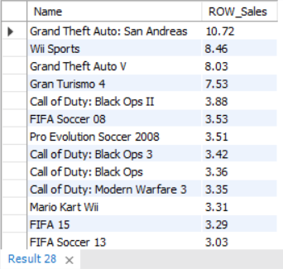

1. Publisher with most games

SELECT Publisher, COUNT(Publisher) as total_games_released from vgsales

group by Publisher

order by total_games_released desc;

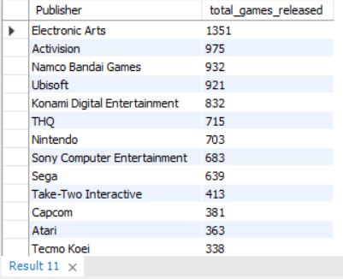

1. Best platform by sales

SELECT Platform, cast(Sum(Global_sales) as decimal(10,2)) as total_platform_sales

from vgsales

group by Platform

order by total_platform_sales desc;

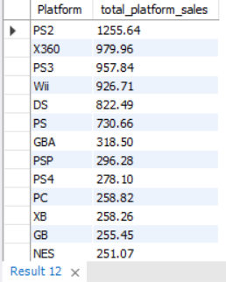

1. Platform with most games

SELECT Platform, COUNT(Name) as total_games_platform

from vgsales

group by Platform

order by total_games_platform desc;

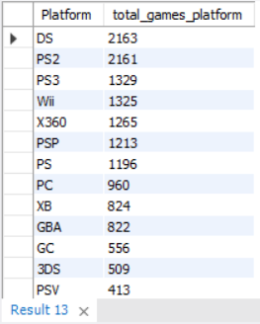

1. Top publisher with most games sold by year

SELECT Publisher, COUNT(Name) as total_games_published, CAST(SUM(Global_sales) as decimal(10,2)) as total_sales

from vgsales

group by Publisher

Order by total_sales desc;

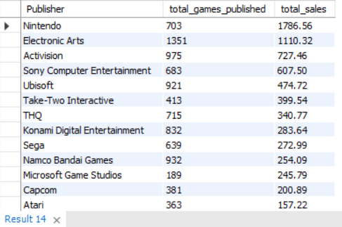

1. Most games released in a year

SELECT Year, count(Name) as total_games_published

from vgsales

group by Year

order by total_games_published desc;

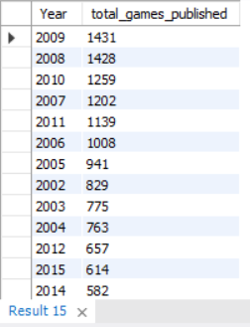

1. Avg sales as platform

SELECT Platform, Cast(AVG(Global_sales) as decimal(10,2)) as Avg_sales_platfrom

from vgsales

group by Platform

order by Avg_sales_platfrom Desc;

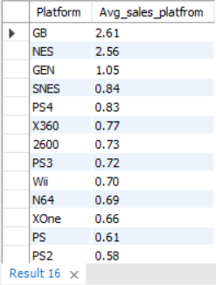

1. Publishers having greater than avg global sales and total games greater than 5

SELECT Publisher, Cast(AVG(Global_sales) as decimal(10,2)) as Avg_sales_publisher

from vgsales

group by Publisher

Having Avg_sales_publisher >

(select avg(Global_sales) from vgsales) and count(Name) > 5

order by Avg_sales_publisher Desc;

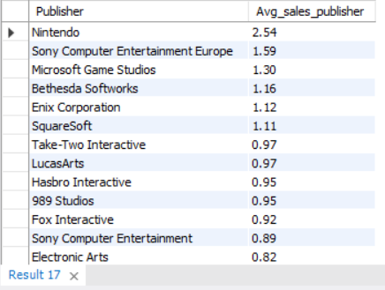

1. Percentage games per platform

SELECT Platform, (Count(Name) *100) / (select Count(Platform) from vgsales) as percentage

from vgsales

group by Platform

order by percentage desc;

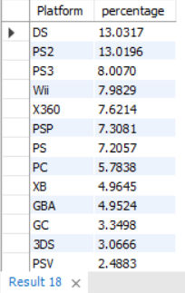

1. Percentage games per genre

SELECT Genre, (Count(Name) *100) / (select Count(Genre) from vgsales) as percentage

from vgsales

group by Genre

order by percentage desc;

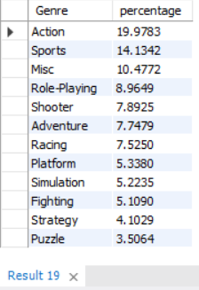

1. Publisher with the highest percentage of total global sales.

SELECT Publisher, CAST(count(Name)*100/ (select sum(global_sales) from vgsales) as DECIMAL(10,2)) as sales_percent

from vgsales

group by Publisher

order by sales_percent desc;

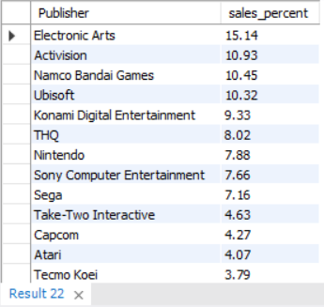

1. Genres with the highest standard deviation of global sales

select Genre, CAST(stddev(Global_sales) as DECIMAL(10,2)) as sd

from vgsales

group by Genre

having count(name)>5

order by sd desc;

